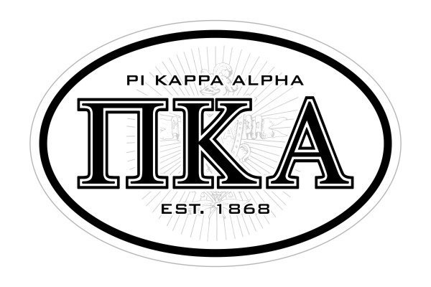
Brothers,
Please join me at this year’s Alumni Weekend April 27th and 28th. Please forward to all of our brothers as we would really like to have a phenomenal turnout this year.
Friday April 28th
Alumni Cocktail Party
Pi Kappa Alpha Mansion
1401 North Sprigg Street
Cape Girardeau, Mo 63701
Drinks and Appetizers Provided

Saturday 9am shotgun start at Cape Girardeau Country Club
4-man Scramble
$65 per person includes bloody mary, lunch, and beer.
Team Mulligans $20
Team Skins $30
______________________________________________________
Contact Robbie Guard with Payment and signup options or send check made to EI Alumni Association to:
Robbie Guard
1610 N. Kingshighway Suite 102
Cape Girardeau, Mo 63701
rguard@mrvbanks.com
573-450-3396

Player 1:_____________________________________
Player 2:_____________________________________
Player 3:_____________________________________
Player 4:_____________________________________
Total Enclosed ________________________

